EURIG

Minutes of the Members’ Meeting, 2018

Hosted by DBC

Ballerup, Denmark 24-25 May 2018

**Content**

1 Welcome and introductions 3

2 Minutes of the previous meeting and matters arising 3

3 Annual Report and Membership Update 4

4 Report of the Europe Regional Representative to RSC 5

5 Working Group Reports 9

5.1 Fictitious entities Working Group 9

5.2 Music Working Group 10

5.3 Places WG 10

5.4 Rare Materials WG 10

5.5 RDA/ONIX Framework Working Group 11

5.6 Relationship Designators Working Group 11

5.7 Technical Working Group 11

5.8 Capitalization Working Group 11

5.9 Translations Working Group 11

5.10 Aggregates Working Group 11

6 Discussion of 3R Project 12

Members: 13

Rita Albrecht 13

7 Presentations 13

7.1 European BIBFRAME meeting, Germany, September 2017 13

7.2 The new Libris 14

7.3 Taking RDA to the next level 14

8 Future meetings 14

8.1 RSC Meeting Montreal October 2018 14

8.2 European BIBFRAME meeting, Fiesole, September 2018 14

8.3 EURIG Members’ Meeting 2019 14

9 European Representative and EURIG Committees 15

9.1 Recommendation of European Representative to RSC 15

9.2 Editorial Committee 15

9.3 Executive Committee 15

10 Communications and Any Other Business 15

11 Close 15

Appendix 1: Attendees 16

Appendix 2: Objectives and outcomes 2017/2018 17

Appendix 3: EURIG Annual Report 2017-2018 19

Appendix 4: Report of the Europe Regional Representative to RSC 21

Appendix 5: The new RDA Toolkit 29

Appendix 6: Relationship Designators WG Report 35

Appendix 7: Aggregates WG Report 38

Appendix 8: Workshop: European cataloguing – further cooperation and involvement 42

Appendix 9: Report from the European BIBFRAME Workshop 2017 50

Appendix 10: The new Libris 61

Appendix 11: Taking RDA to the next level 62

***The Business Meeting was restricted to members and invited guests only***

# Welcome and introductions

The Chair (Hanne Hørl Hansen) welcomed everyone to this year’s members’ meeting and gave an overview of the DBC. There was a short round of introductions, including the designation of a representative from those institutions which sent more than one person to the meeting.

The Chair sent regrets from those members who were not able to attend. A list of attendees is attached as Appendix 1.

# Minutes of the previous meeting and matters arising

The minutes of the previous meeting were reviewed. No further comments or business based on the minutes were received; the minutes were approved.

Actions from the 2017 Member’s meeting:

**8.2 Election of RSC Europe Region Representative**

***Done:*** There was only one nomination (Renate Behrens). EURIG nominated her as our representative; the nomination will be sent to the RSC and the RDA Board for their approval. An assistant representative (Ahava Cohen) was appointed.

**8.3 Editorial Committee**

***Done:*** Two new members(Alan Danskin and Stefano Bargioni) joined the Editorial Committee.

**Implementation Survey**

***Done:*** A short implementation survey was conducted starting in September 2017.

**Website Migration**

***Done:*** The EURIG website was migrated to the RSC website in June, 2017, by the Executive Secretary with the help of the British Library.

**Update and publish list of experts to support Working Group representatives**

***Done:*** Experts on previous lists were contacted and a revised list was uploaded to the EURIG wiki. Additional experts are always welcome to volunteer.

**Develop EURIG policy document to clarify working practices, with reference to principles agreed in Riga**

***On hold:*** Awaiting post-3R changes to RSC procedures

**Propose earlier deadline for RSC papers (June) to RDA Board and a minimum reponse time for working groups (10 working days) to allow for translation and consultation**

***On hold:*** Awaiting post-3R changes to RSC procedures

A full list of outcomes of objectives set at the 2017 annual meeting and the progress towards meeting those goals is attached as Appendix 2.

# Annual Report and Membership Update

The Chair went through the highlights of the annual report, attached as Appendix 3.

We met all our objectives for last year aside from those dependent on the progress of the 3R project.

***The Executive Committee consists of:***   
Hanne Hørl Hansen (Chair)  
Marja-Liisa Seppala (Vice-Chair)  
Ahava Cohen (Executive Secretary)  
Renate Behrens (RSC Representative, ex-officio)  
Ulrike Junger (RDA Board, ex-officio)  
The committee has held Skype meetings over the year to discuss EURIG business and 3R.

***3R***

The main occupation of the Executive Committee has been 3R and the new Toolkit. We don't want to stop the development of RDA, just make sure that our members can keep up with the developments and adopt/translate them in time. The Committee wrote a letter to the RSC and the RDA Board to express concern about the time frame after which the old Toolkit will be unavailable and about national profiles which may lead to different flavors of RDA. Translating 3R, creating policy statements, and managing changes in workflows means that implementing 3R will take a long time. EURIG members were asked for comments and they provided helpful comments before the letter was sent.

Concern was raised that the RSC core team did most of the work of adapting RDA to 3R; this is a worrying development and against the principle of democratization of RDA. Instead of a community driven rule set 3R is a top-down set of guidelines.

It was noted that RSC members had a chance to see and comment on documents before the October, 2017, meeting in Madrid and that communities can comment on the beta version of the Toolkit. Questions were raised about the value of writing such comments, but the Regional representative (Renate Behrens) said that the comments do indeed have value.

The Regional representative further said that we have to develop a European strategy and that for the commenting phase we should have a strategic point of view. The RSC meeting at the end of October, 2018, will give us a chance to demonstrate this strategic point of view.

Alan Danskin noted that most of the content for 3R is from the working groups, and that's the way to make EURIG voices heard. In her presentation Renate showed the extent of EURIG participation in working groups.

Hanne Hørl Hansen noted that it's hard to say what 3R will be until we see 3R. Simon Berney-Edwards of the RDA Board has reassured us that RDA is still a code for cataloguing and we have to give him the benefit until and unless we see otherwise. We also have to realize that this is a big change in RDA and it is difficult to keep it all consistent over the entirety of the chapters. Bernhard Schubert said that in order to have new rules accepted they have to be practical. So far all we've seen of 3R is abstract.

Alan Danskin reported that discussion of policy statements in 3R is only beginning; there will be a voice conference about the nature of policy statements at end of month.

Renate Behrens said that the RSC is very open to European thoughts, but the procedure for making those thoughts heard is not yet set.

***Membership update***EURIG now has 45 members from 27 countries.  
We welcomed three new members this year:

* URBE - Unione Romana Biblioteche Ecclesiastiche, Italy
* National Széchényi Library, Hungary
* Danish Royal Library, Denmark

No other comments were made on the Annual report.

# Report of the Europe Regional Representative to RSC

Renate reported on the work of the Europe Regional Representative to RSC. Her report is attached as Appendix 4.

The European region has quickly become a stable partner in RSC and RDA Board – not a trivial process. Other communities are still working on creating themselves. The various language based communities in Europe have been contributing to RDA via EURIG, some through translators' meetings and some through the editorial committee.

Our organization means that we have been able to participate in the "small things." EURIG proposals go to the editorial committee and then to RSC. The editorial committee has also been drafted to go over initial proposals and drafts. June will see release of part of 3R (the entity chapters) – the editorial committee will have to work over the European holidays to comment on these sections.

The editorial committee is very international. Therefore it only meets by phone/wiki, as it would cost too much to meet in person. This is not an easy way to work, but it has been successful.

RDA governance: EURIG is represented on the RDA Board by Ulrike Junger and on the RSC by Renate Behrens. Both roles are major tasks; it's a lot of work to represent a whole continent.

The RSC has no members from Asia, Africa, or Latin America (the latter has a member on the RDA Board). The process EURIG went through to become an RDA region is taking longer for other continental communities. NORDAC (North America) is coming together – Thomas Brenndorfer is the regional representative, with Kate James as backup. ORDAC (Oceania) had to change their regional representative as Ebe Kartus has taken on the role of Wider Community Engagement Officer and will help include non-library communities and other under-represented communities under the RDA umbrella. The new ORDAC representative is Catherine Amey and her backup is Melissa Parent. Catherine has suggested that the regional representatives band together to discuss programs and issues.

RSC is changing chairs at the end of 2018 – Gordon Dunsire is stepping down and Kathy Glennan will step in. Kathy has been the ALA representative to the RSC and is very familiar with everything to do with the committee.

**Working Groups:**

The second face to face meeting of the Translation Working Group was held on May 23, 2018, just prior to the EURIG annual meeting. (The first was held in conjunction with the RSC meeting in Madrid, October 2017.) Observers (including those working on partial translations) were welcomed at the meeting. These wider meetings will help give those who are doing the translations a stronger voice on the RSC.

In general, more experts and members are needed for the working groups.

The Rare Materials Working Group is a good example of international communication.

Rita Albrecht asked about RSC plans to create more Working Groups – Renate Behrens said there may be new groups after 3R. During 3R the chairs of Working Groups joined discussions as part of RSC+. In October, 2018, there will be discussion of the structure of RSC and its relation to Working Groups. Those who have thoughts about the relationship and about topics which need Working Group input should contact Renate Behrens.

**3R project:**

Two meetings were held in 2017 – Chicago in May, Madrid in October. About 1000 documents were changed on the wiki and many more were discussed in Google Docs and emails. Consensus was not always reached nor were solutions always offered (for example, fictitious entities). There will be several new issues in the Toolkit (for example, how to treat fictitious entities in practice and what to do with aggregates). The less trivial issues are the harder they are to deal with – that's part of the reason why the June release is only beta and is not final.

The June release will include English text only. There will be further updates in September and December with the last release in February, 2019. The old Toolkit will be available for one year after the end of the 3R project. The question of "what constitutes the end of the 3R project?" was raised during the second translation meeting. Jamie Hennelly of ALA Publishing said that the stakeholders, the RDA Board, and the RSC must all agree that "3R is finished." After June the comment phase opens and EURIG should respond strategically – we are the region with the most translations. The translation tools work very well, but we have to wait to see what will be available in the beta Toolkit come June 13.

As 3R materials are written national and language communities must review translations, working documents, and training materials (for example, instruction numbers must be removed). The process will mean we need to build international communication and plan a review process which works for Europe. Further international work on the 3R review process will be discussed in October at the RSC meeting.

EURIG's objective is to have RDA seen as an international standard with equal partners from around the world.

**The beta Toolkit:**

Renate Behrens showed slides of the beta Toolkit (attached as Appendix 5). In the beta version, the Toolkit is no longer a parking spot for pdfs; it is a true web based platform.

Germany uses a wiki for training materials and has found that people use the training materials (now frozen) instead of Toolkit. Therefore the German community plans to put things in the beta Toolkit instead of in a wiki in the hopes this will encourage use of Toolkit.

Renate explained the menus and then focused on the entity chapters. They are listed in LRM order – instruction numbers are disappearing as will the left-hand side navigation pane. The promised graphical browser will not be in the first release.

Policy statements will be in Toolkit, not as button within the text but on the right side, as clickable "related policies" which can be shown or hidden based on preferences. Favorites can be set and users can hide sources of policy statements which they don't want to work with. Policy statements will show a certain number of lines and the rest will be accessible through a "read more" link.

Recording methods (formerly "the 4 fold path") will be available as a section which can be expanded or collapsed. Alan reported that there will a discussion of exceptions, options, and alternates to guidelines. The RSC+ felt they should be retained. Other features in the beta Toolkit: Glossary terms which are defined on mouse-over, bookmarks, notes, and URLs to share or to use in documents.

"Release notes" will keep a list of what has changed; this is especially important for translators. These notes will always be available for the past few years and the rest will be archived by ALA Publishing.

Renate explained that the wording from the old version of Toolkit has been placed into the beta version where relevant. Entity chapters are pretty much fixed, but there still may be some changes. We must think about how to start work with policy statements.

Alan Danskin noted that the current appendices will be distributed throughout the beta Toolkit.

Renate reminded everyone that ALA will work with libraries – consortia licenses are available. Printed versions of RDA become out of date very quickly.

**Policy statements:**

Marja Smolenaars asked how to deal with policy statements and documents which have instruction numbers. Alan answered that behind the scenes the instruction numbers still exist, but not everything will map as it had before because of changes to the guidelines. Renate Behrens said that the old numbers will be searchable, but when revising policy statements it might be worthwhile to switch to RDA terms instead of numbers. Hanne Hørl Hansen asked about training materials: You can put a link in your documents, but you need to give the link a name which bears information. People knew what Chapter 2 included, but who knows what an IRI refers to?

**Core elements:**

Hanne also asked about Core elements. Renate said that Core will no longer be in the text itself, but the idea might be described in the guidance chapters. Core elements may have to be set as part of a national/language standard. Alan Danskin said that in Madrid the RSC spoke of Core elements as being so dependent on what was being described that there is no way to create a universal set. He suggested we try to formulate a position as part of the beta comment process.

Hanne said one approach might be to state that a certain core set of elements is required in order to state that something is RDA. Alan said that it's complicated because of the recording methods – you could put something in that's RDA compliant but is not useful for other libraries. Rita said "core elements" might not be helpful in a flexible environment and we might need a different way to define a set of information.

Alan said that RDA is a framework+ (gives instructions, but also flexibility) so core elements might not be something it can define. Communities which want to share data might have to build a mutually agreeable application profile. Also, if an agency declares what recording method were used others will know what they're getting, but RDA does have to accommodate both fully unstructured data and fully IRI data. Bernhard Schubert asked what the advantage of calling our legacy data RDA is. Alan clarified that naming a standard allows people to manage their expectation about what they'll find in the record.

Renate pointed out that core elements don’t serve other collection communities. Alan talked about using publisher metadata for immediate availability, and that RDA will accommodate such metadata and also enhanced/corrected records. She suggested that core elements be a topic for next year, after we've gained experience with 3R.

Rita Albrecht said that when exchanging data we compare the format of the data more than the instructions is use. This is different than NORDAC, which uses WorldCat, speaks MARC, and follows LC. Europe is more diverse. Alan said that we also work with ONIX. Rita agreed and added that ONIX is an added complication. Hanne Hørl Hansen said there should be a way to qualify/declare the reliability of data and its format.

The British Library has taken on responsibility for mapping RDA to MARC 21. The mapping will make it more explicit which recording method is in the field, but such information can't always be determined. Bernhard Schubert said that we need meta-metadata so we can know, for each element, what recording method was used.

There were complaints that the RDA FAQ states no systems can handle full RDA; it is frustrating that even officially they say "we can't do it." We do need a system which can. BIBFRAME can't: it doesn't work with LRM or even fully with FRBR. The British Library would like a system which could handle all of RDA, but there's nothing out there. They've talked with other national libraries and are working with the Library of Congress to create a list of things they need. MARC has been very successful and thus has become something of a straightjacket.

**Application profiles:**

Marja-Liisa Seppälä asked about the role of application profiles. Renate Behrens said that they're more and more important for language-based communities and collection based-communities – they are detailed instructions for a subset of the cataloguing world. Renate would like to discuss application profiles with the EURIG community.

Rita Albrecht asked about family as an entity. Alan Danskin said that it's a subclass of agent, under the subcategory of family. Bernhard said that it's not in LRM, but has been retained in RDA. Alan said it's an important concept, for example for archives. Communities creating implementations of LRM can define their own terms, which is what RDA is doing with family.

Stefano Bargioni asked about an API which would allow accessing RDA information through other software. Alan stated that the Registry has an API. Stefano said that currently his staff can, during the cataloguing, call up the RDA instruction. Alan said he didn't think any functionality would be lost in the new Toolkit. Jamie Hennelly should be asked for specifics – if this is functionality which will be ported.

Renate invited feedback on the features/technical aspects of the beta Toolkit as well as the content. She said that the Executive Committee will report concerns back to the RSC. Hanne said that we should also use the concerns as a checklist to see the ultimate Toolkit response to the list.

# Working Group Reports

## Fictitious entities Working Group

Stefanie Zutter reported that the WG wrote a paper submitted to the RSC in September 2017. The new theoretical underpinning of RDA, LRM, seeks to be broader base for other parts of the metadata world (GAM). They look at "people" in a different way than we do – libraries don't care if the person was a biological person (for example Homer or Shakespeare) – but what do you do with an author that we know didn't exist, like Lemony Snicket? Fictitious entities aren't people, so they can't be "agents" in LRM. How to deal with them is what the WG dealt with the past year. The WG decided to follow LRM, but know that this path might not be helpful to the user. Expect more discussion after June 13.

We need practical instructions/use cases for how to deal with the implications of the new conceptual model. Relationship designators could be shortcuts which connect the title to the fictitious entity.

Bernhard Schubert said that there had been some discussion about fictitious entities on RDA-L, where a good summary was posted.

Hanne Hørl Hansen said she'd heard that fictitious entities would be nomen. Alan Danskin explained that Lemony Snicket would be recorded in the statement of responsibility and the system would lead to the people behind the fictitious entity, but the fictitious entity wouldn’t have the same sort of authority record as a real person. Persons are split from the names we call them.

Hanne asked if fictitious entities can be creators. Alan said we can assume *someone* created it, so we can say the fictitious entity's nomen is a shortcut to the true person and we can add a relationship designator on the fictitious entity

Rita Albrecht asked whether the fictitious entity would be recorded in the same field as it would be if it were a real person. Alan said that there will be a discussion of fictitious entities in MARC at ALA Annual as well as discussion of whether we should even spend time adapting MARC. Alan feels it won't change at present. Françoise Leresche said that in current production we cannot know if the name in the statement of responsibility corresponds to a real person. Alan said you can establish the name without establishing an authority behind the name.

Hanne said we should look at what is proposed when we see the new Toolkit. Renate Behrens said nomen will not be in the first release. Renate noted the issue of GDPR – we can't put the pseudonym in the same authority record as the real person's name. Hanne pointed out other privacy issues – like gender, DOB, place of residence. She thinks there are exceptions for databases with public purpose. BL is taking that path, but information has to be justified.

## Music Working Group

Anders Cato said the Working Group is on hold until after 3R.

## Places WG

There was no activity within this Working Group.

## Rare Materials WG

Michael Beer reported on the activity of the WG, which was less than had been expected. The WG had wanted to introduce changes to items, but deferred until after 3R. They did work on the RDA labels. There were no new tasks assigned after Madrid, which was understandable; introducing changes at this point would be difficult. The WG expects there to be more work after 3R is complete.

The WG may work on topics like the history of items and metadata. They may wish to collaborate with an archive WG (which does not exist at this time) as they know that museums and archives are also interested in these issues.

RBMS-PS (created by ALA Rare Books & Manuscripts section) is being formulated to reconcile DCRM and RDA; it could also interest European libraries. DACH does not have separate instructions for rare materials. There is no European initiative yet to catalog rare books and manuscripts – should we make one? Renate: In Bern we said we wanted fewer EURIG groups, more cooperation on international WG. Hanne said we should discuss this in the workshop. The meeting talked about the danger of having RDA, European policy statements, national policy statements, and local policy statements –catalogers would get lost. It might be better to invest in examples which would lead to discussions to be taken to RSC rather than make European policy statements.

Renate said that there are standards in the world for things like manuscripts, but they’re not in use in all communities.

Rules for items are sparse in RDA, but this is not good for researchers.

Marja Smolenaars talked about how to link former owners with specific copies. This can be done with manuscripts (manifestation singleton) not for manifestations with multiple copies. The limitation is more a system issue than an RDA problem. Bernhard Schubert said that the RDA rules for items are also underspecified.

Michael Beer stated that rare books and manuscripts are often cataloged using a different vocabulary so it will be difficult to reconcile with RDA.

Renate informed the meeting that there will be a conference in July in London about artists' books and they are planning to create a cataloguing toolkit. This should be reconciled with RDA.

## RDA/ONIX Framework Working Group

Alan Danskin reported that there was nothing to report.

## Relationship Designators Working Group

Maira Kreislere submitted a report, added as Appendix 6 to the minutes.

## Technical Working Group

Marja-Liisa Seppälä reported that the working group had not been active last year.

## Capitalization Working Group

Marja-Liisa Seppälä reported that the working group had not been active last year.

## **Translations Working Group**

Marja-Liisa Seppälä reported that the working group had not documented activity over the last year.

## **Aggregates Working Group**

The report of the Aggregates Working Group is attached as Appendix 7.

Françoise Leresche reports that the WG has worked hard this year via phone conferences and Google Docs. They have prepared discussion papers for the two RSC meetings. For the Chicago meeting they proposed a model for dealing with aggregates in RDA based on LRM, distinguishing between whole-part and aggregating relationships. Collaborating works (amalgamated content) also required discussion as did the different kinds of descriptions, container relationships, and agent-to-WEMI relationships. Not all proposals of the WG were accepted by the RSC. After the Chicago meeting the WG was asked to create one of the general chapters (pre-cataloguing decisions) and they are working on it.

During the summer IFLA meeting, the WG met with RDA, ISSN, ISBD, FRBR representatives, (including Clément Oury and Françoise) about LRM elements and their impact on cataloguing standards. The group discussed serials and seriality as a critical aspect of **work** and WEM lock. A global notion of continuing resource should be added to RDA.

The WG group set up subgroup (including Clément) dealing with serials. Their decisions were accepted by the WG and were included in a report presented to the RSC Madrid meeting. This report added the concept of diachronic (determinate/indeterminate) works with successive or integrative content. The WG is still working on a general description of continuing resources.

Hanne Hørl Hansen asked about the joint discussion paper with the Relationship Designator group? Françoise Leresche reported that in principle the paper has been agreed upon, but the groups are still working on the terms, shortcuts, and details.

Bernhard Schubert said that he used to be a fan of the WG report, but it doesn't fit with the focus on user tasks. Increased abstraction doesn't serve the reader; how should cataloguing staff deal with this? The shortcuts need to be easily understandable. Françoise feels the general chapter is too abstract in some ways, but the rules show the consequences and are clear. The analysis takes into account the work of the RDA/ONIX WG.

Renate Behrens said that general chapters are for the expert teams. They train the working catalogers via operationalized guidance (application profiles).

Rita Albrecht said that there is no entity chapter on aggregates – where are the rules to use in day-to-day work? Renate said that the place for these rules is within policy statements. Françoise said there will be parts of relevant entity chapters discussing their application to aggregates.

Hanne noted that at this point we're still guessing about the contents of 3R. The Editorial Committee needs to pay attention to aggregates when reviewing 3R.

# **Discussion of 3R Project**

***Discussion groups:***The attendees broke up into groups to discuss European responses to 3R. A combined report of these groups is attached as Appendix 8.

The main take-away was that everyone is waiting to see what 3R turns out to be.

European groups might be useful to create pressure on library system vendors.

It is unclear whether it pays for EURIG to work locally and then internationally or vice versa; much depends on topic under discussion.

Renate suggested that the Executive Committee check which WG need a boost of European participation. In addition, Kate James (the RDA Examples Editor) has asked for examples in our native languages. We can start from that and make a bundle of European examples as a good compromise between local and international action; creating asset of examples would be acting on both a European and an international level.

*The discussion of 3R continued on Friday, May 25.*

Renate took up Thierry Clavel's suggestion, made during the Thursday workshop, for a WG to look at new Toolkit not from an editorial point of view but from a technical one. The comment phase ends in September and Renate wants input from Europe before the RSC meeting in October. Hanne will issue a call for volunteers. Those volunteering at the Annual Meeting:

Thierry Clavel- chair.

Members:

Jenny Wright

Alan Danskin

Katarina Synnermark

Stefano Borgioni

Roberto Gómez Prada

Marja-Liisa Seppälä

Jane Makke

Michael Beer

Bernhard Schuberg

Rita Albrecht

# **Presentations**

## European BIBFRAME meeting, Germany, September 2017

Leif Andresen reported on the European BIBFRAME Meeting held at the Deutsche Nationalbibliothek in Frankfurt am Main, Germany on 26-27 September 2017. His report is attached as Appendix 9.

The workshop is not a formal organization like EURIG; the need for knowledge is not European specific. The workshop created a list of expectations for ILS tenders, including ten levels of BIBFRAME implementation.

How will BIBFRAME deal with LRM? Leif said that there isn't a whole lot of difference between a system working with FRBR or LRM. Bernhard Schuberg noted that BIBFRAME doesn't seem to be as granular as RDA and asked why are we starting out with a simplistic view and trying to cram it all in instead of starting from RDA vocabularies and then simplifying records for data exchange. Françoise Leresche agreed: BIBFRAME seems to be built as a MARC substitute instead of a way to code RDA. Line said that at the BIBFRAME workshop it was said that RDA and BIBFRAME started out together, that RDA is influenced by MARC 21 and that BIBFRAME is "a metadata haircut." Renata reminded everyone that new RDA is not MARC-ish. Alan Danskin said that a fundamental mistake was made when BIBFRAME was set up – BIBFRAME is not a model, it's a schema. It gives less than MARC, so moving to BIBFRAME is a false step.

Leif stated that if you want a perfect standard you will not have a standard.

## The new Libris

Olle Johansson and Katarina Synnermark presented the new Swedish union catalogue. Their presentation is attached as Appendix 10.

## Taking RDA to the next level

Line Jung Lindhard of DBC presented the Danish considerations and scenarios for the implementation of RDA. Her presentation is attached as Appendix 11.

RDA will be adopted in Danish MARC, but they will try to do some IFLA-LRM entities.

The machine learning project didn't work at the level DBC wanted because they did not have authority files to work with. It's an iterative process. Since they are not working in MARC21 they can't use all the crosswalks available and so machine learning is the best way forward.

# **Future meetings**

## RSC Meeting Montreal October 2018

The 2018 RSC meeting will be held at McGill University, Montreal, Quebec, Canada on October 23-25.

## European BIBFRAME meeting, Fiesole, September 2018

Leif Andrsesen reported on the planned meeting as part of his presentation on BIBFRAME.

## EURIG Members’ Meeting 2019

There was a discussion of the optimal length of the EURIG annual meeting. Roberto Gómez Prada stated that it depends on whether there's a preconference on a related topic, and particularly suggested the issue of data modelling. Marja Smolenaars said a seminar about implementation (linked to, but not the same as, RDA) could be useful, but not every library would allow people to go to a pre-conference. Therefore it might be best as part of the annual meeting. Françoise Leresche pointed out that in 2019 we will be able to once again make proposals to the RSC and will need time to discuss and vote, but Rita Albrecht said we might not be interested in making suggestions during 2019 because we'll be busy implementing 3R.

Ideas for EURIG 2019:

* Implementation of 3R and creation of training materials
* An annual update about BIBFRAME/data modelling
* Jenny Wright about BDS's non-MARC projects
* Updates about the Swedish Libris project
* Updates from the BnF
* How LRM can be used to rationalize workflows

It was recommended that the 2019 meeting be once again a day and a half long.

# **European Representative and EURIG Committees**

## Recommendation of European Representative to RSC

Renate Behrens’ term as interim representative ends in 2018. Nominations were requested for someone to fill this role from 2018-2021. The only person nominated was Renate Behrens, and she was unanimously recommended to the RDA Board and RSC for appointment.

***Action: all.***

## Editorial Committee

The Chair requested further nominations for members of the Editorial Committee. Duties of the Editorial Committee are described in the Cooperation Agreement.

***Action:*** all.

## Executive Committee

In 2019 we will be holding elections for Executive Committee. Members can't hold the same office for more than one consecutive term. In terms of succession planning, some of the current Executive Committee should stay on in new roles and some new members should be elected. A call for candidates will be issued in late 2018.

***Action:*** Executive Committee

# **Communications and Any Other Business**

Outreach to non-members: In 2018/2019 the Executive Committee will attempt to identify and recruit European cataloguing agencies which are not yet part of EURIG, particularly from areas of Europe in which we are under-represented.

Twitter: @EURIGRDA The Executive Committee asks attendees to upload pictures from the meeting. Renate Behrens requested permission to use people's photos in EURIG publicity.

The Executive Committee thanked DBC and Hanne Hørl Hansen on behalf of EURIG for organizing and hosting the meeting.

# Close

The Chair thanked everyone for a productive meeting.

# Appendix 1: Attendees

|  |  |  |
| --- | --- | --- |
| **Country** | **Name** | **Institution** |
| Austria | Bernhard Schubert | Austrian Library Network |
| Czech Republic | Jarmila Přibylová | National Library of the Czech Republic |
| Croatia | Ana Vukadin | National and University Library in Zagreb |
| Denmark | Anders Cato | Danish Agency for Culture and Palaces |
|  | Hanne Hørl Hansen  Leif Andresen | Danish Bibliographic Center, DBC  Royal Danish Library |
| Estonia | Jane Makke  Kadi Mälton | National Library of Estonia  National Library of Estonia |
| Finland | Marja-Liisa Seppälä  Tatja Pusa | National Library of Finland  National Library of Finland |
| France | Françoise Leresche | Bibliothèque nationale de France |
| Germany | Michael Beer  Renate Behrens  Rita Albrecht | Bayerische Staatsbibliothek  Deutsche Nationalbibliothek  Consortium of Library Networks |
| Hungary | Szabolcs Dancs | National Széchényi Library |
| Iceland | Hallfriður Kristjansdottír | National and University Library of Iceland |
| Israel | Ahava Cohen | National Library of Israel |
| Italy | Giovanni Aldi  Stefano Bargioni | Casalini Libri  URBE |
| Lithuania | Linas Salelionis  Violeta Kostinaité (observer)  Gelmina Petrauskie (observer) | eLABa Consortium  eLABa Consortium  Vilnius Gediminas Technical University |
| Luxembourg | Stefanie Zutter | Bibliothèque nationale de Luxembourg |
| Netherlands | Marja Smolenaars | National Library of the Netherlands |
| Norway | Frank B. Haugen  Trine Adolfsen (observer) | National Library of Norway  National Library of Norway |
| Poland | Leszek Śnieżko | NUKAT Center of Warsaw University Library |
| Slovakia | Martin Krejčí  Juraj Valko (observer) | Slovak National Library  Slovak National Library |
| Slovenia | Irenca Kavčič | National and University Library of Slovenia |
| Spain | Roberto Gómez Prada | National Library of Spain |
| Sweden | Katarina Synnermark  Olle Johansson (observer) | National Library of Sweden  National Library of Sweden |
| Switzerland | Christian Aliverti  Thierry Clavel | Biblioteca nazionale svizzera  RERO – Library Network of Western Switzerland |
| Ukraine | Nadiya Strishenetes (observer) | National Library of Ukraine |
| United Kingdom | Alan Danskin  Jenny Wright | British Library  CILIP |

# **Appendix 2: Objectives and outcomes 2017/2018**

|  |  |  |  |
| --- | --- | --- | --- |
| EdCo nominations | All | July 1st | Done  Alan Danskin and Stefano Bargioni joined EdCo |
| RSC Rep Nominations | All | October 2017 | Done, December 2017. DNB nominated Renate Behrens 2019-2021 |
| Website Migration | Secretary & Corine Deliot (BL) | 30th June 2017 | Done  http://www.rda-rsc.org/europe |
| Plan 2018 meeting | ExCo | December 2017 | Done |
| Update and publish list of experts to support WG representatives. | ExCo | June 1st | Done – September 2017 a call was sent out and the list afterwards updated af the EURIG wiki  <https://wiki.dnb.de/display/EURIG/EURIG+-+Editorial+Committee> |
| Issue a template to members to report implementation status and put it on the members page. | ExCo/All | July 1st | Done. A spreadsheet survey was conducted September 2017  [https://docs.google.com/spreadsheets/d/1Cd9HE3xLZUJuk1fYNZK98wOHMZpDSPLsiz2yRSY0Omo/edit#gid=0](https://docs.google.com/spreadsheets/d/1Cd9HE3xLZUJuk1fYNZK98wOHMZpDSPLsiz2yRSY0Omo/edit) |
| Develop EURIG policy document to clarify working practices, with reference to principles agreed in Riga | ExCo | By May 2018 | Not done – waiting for changes in RSC procedures |
| Propose earlier deadline for RSC papers (june) to RDA Board | ExCo & Board Rep | 1st August 2017 | Not done – waiting for changes in RSC procedures |
| Propose minimum reponse time for WG & FT (10 working days) to allow for translation and consultation. | ExCo and RSC Rep | 1st August 2017 | Not done – waiting for changes in RSC procedures |
| Set up planning committee for 2018 Meeting | ExCo & Turkish members | 1st July 2017 | Meeting moved to Copenhagen September 2017. Done |
| Volunteers to host 2019 meeting notify ExCo | All | 1st October 2017 | Done. |

# **Appendix 3: EURIG Annual Report 2017-2018**

Membership

EURIG has 44 member organizations in 27 countries.

 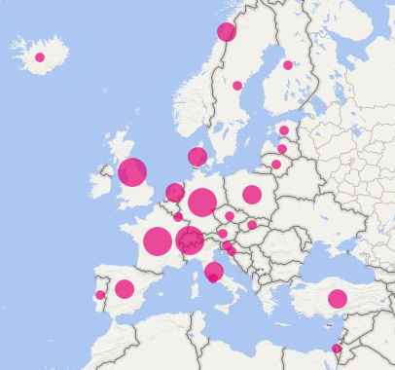

**Members’ Meeting 2017**

The 2017 members’ meeting was held in Florence and Fiesole, Italy, and was hosted by Casalini Libri. The meeting was held in conjunction with the seminar *RDA in Europe and Italy: a reality and a challenge,* hosted by the University of Florence. Papers presented at the seminar were published in the January, 2018, issue of [JLIS.it](https://www.jlis.it/). Further details of the meeting can be found on the [website](http://www.rda-rsc.org/europe/meetings/2017meeting).

**RDA Implementation**

The following implementations were announced in 2017-2018

* National Széchényi Library (Hungary) announced that planning for implementation was underway.
* The National Library of Norway decided to implement RDA from 1st January 2019.

Many other members continued to progress implementations that are already underway. A survey of RDA implementation by EURIG members was undertaken prior to the 2018 Annual meeting and can be found [here](https://docs.google.com/spreadsheets/d/1Cd9HE3xLZUJuk1fYNZK98wOHMZpDSPLsiz2yRSY0Omo/edit#gid=0).

**RDA Development**

The current membership of the Editorial Committee is:

* Renate Behrens (DNB, Chair, RSC Representative)
* Stefano Bargioni (Unione Romana Biblioteche Ecclesiastiche)
* Ahava Cohen (National Library of Israel, Secretary)
* Christian Aliverti (National Library of Switzerland)
* Alan Danskin (BL)
* Hanne Hørl Hansen (DBC, EURIG Executive Committee representative)
* Hallfríður Kristjánsdóttir (National and University Library of Iceland)
* Marja-Liisa Seppälä (National Library of Finland)
* **Christoph Steiger (**University of Music and Performing Arts Vienna**)**

EURIG representatives to the Working Groups are listed in the Europe Regional Representative report, Appendix 4.

Renate Behrens represented the Europe Region at the October 2017 RSC Meeting hosted by Biblioteca Nacional de España in Madrid. Ahava Cohen also attended as backup representative.

EURIG members contribute to translations and to the development and delivery of RDA training throughout the Regions. Translators' meetings were held in conjunction with the RSC meeting in Madrid and with the EURIG annual meeting in Bellerup.

**Communications**

The Executive Committee has migrated the EURIG website to the RSC site.

The Executive Committee and the Editorial Committee continue to rely on DNB’s infrastructure for internal communication.

# **Appendix 4: Report of the Europe Regional Representative to RSC**

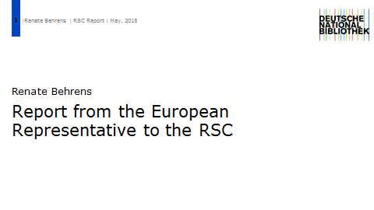

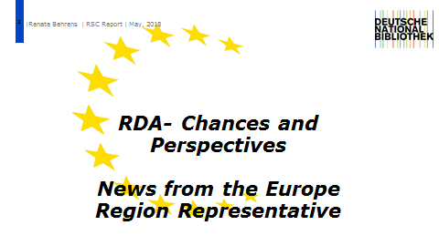

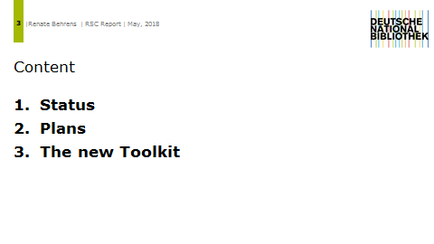 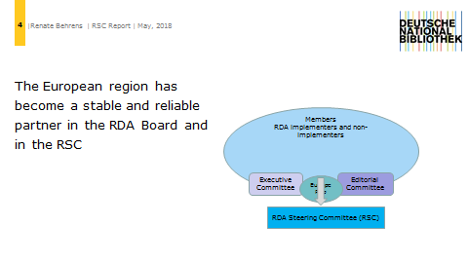 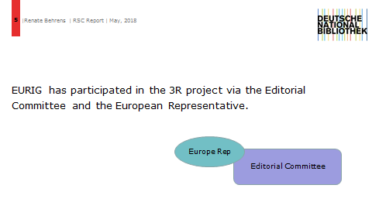 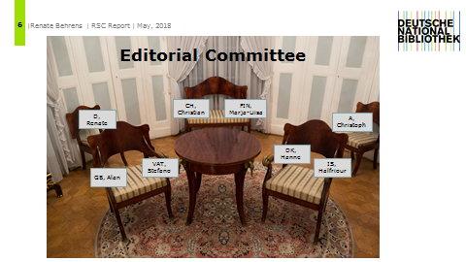 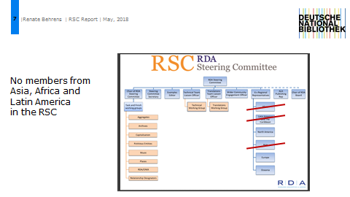 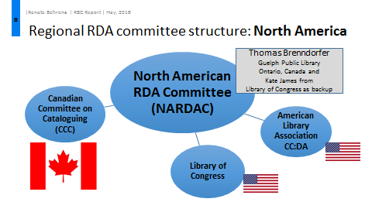 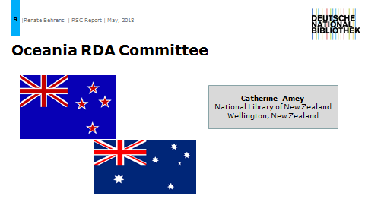 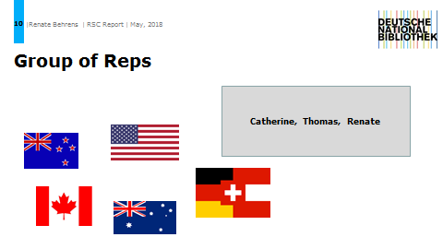 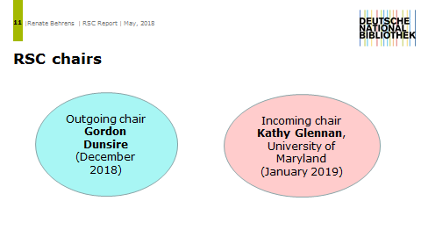 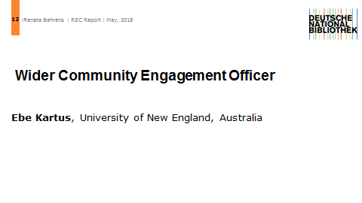 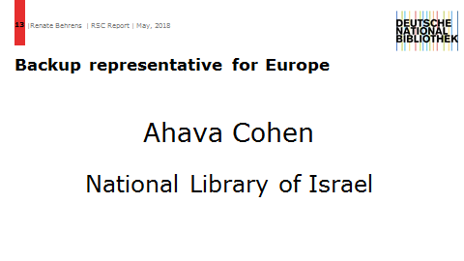 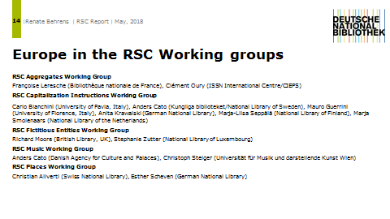 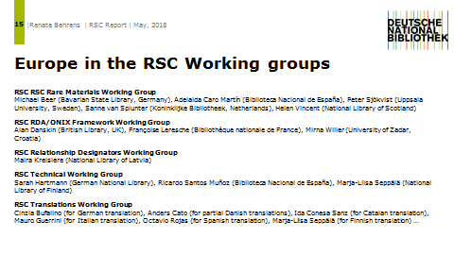 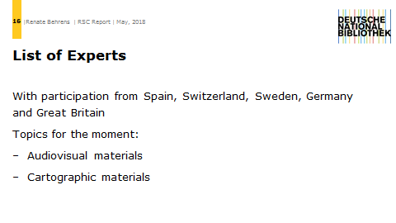 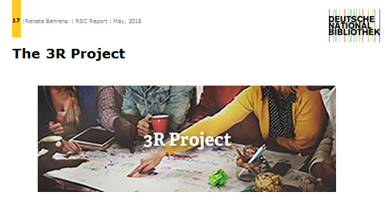 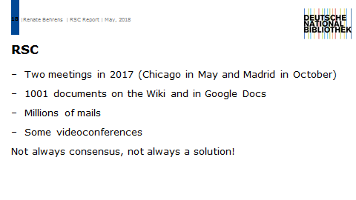 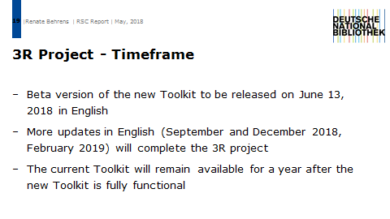 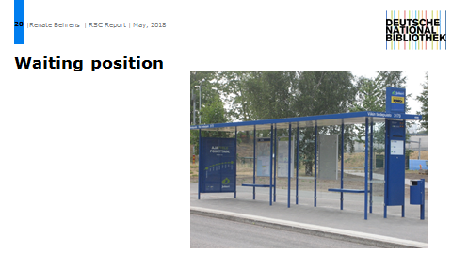 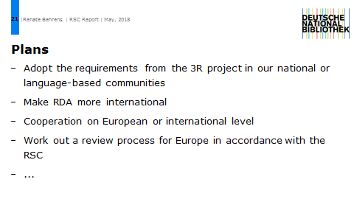 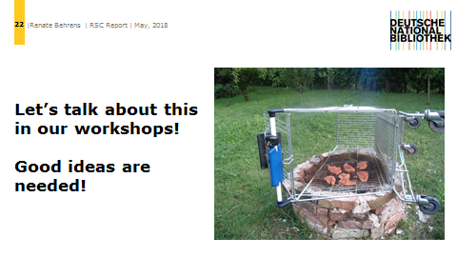

# **Appendix 5: The new RDA Toolkit**

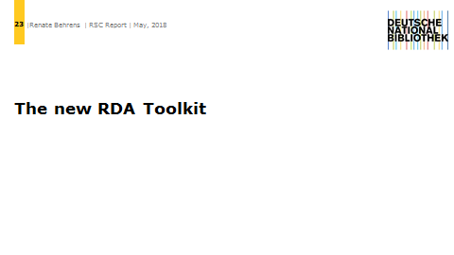 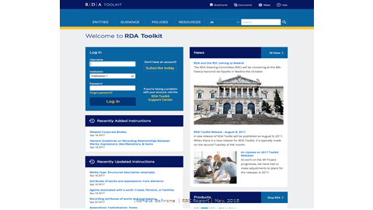 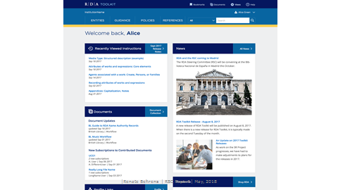 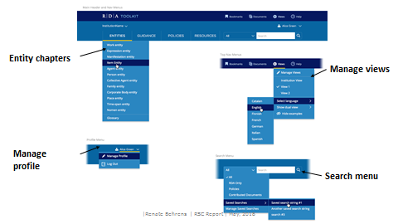 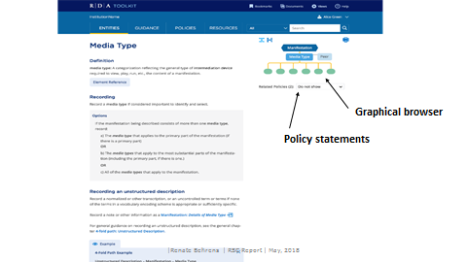 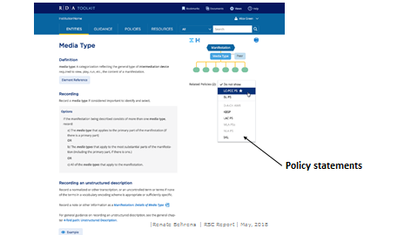 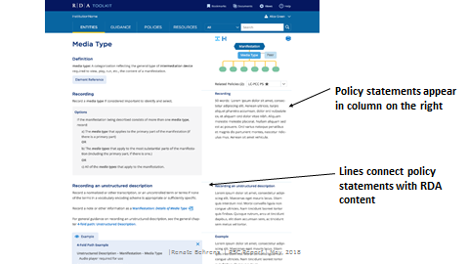 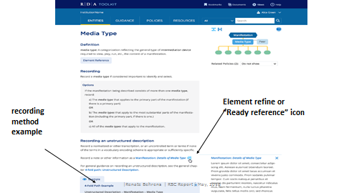 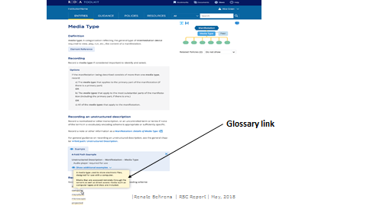 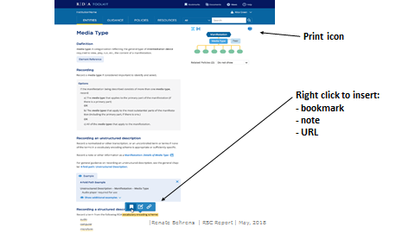 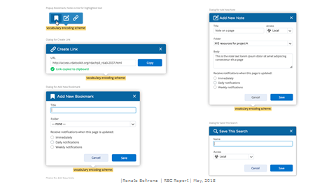 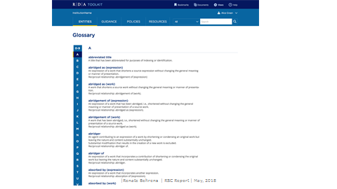 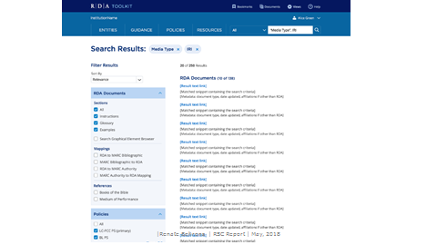 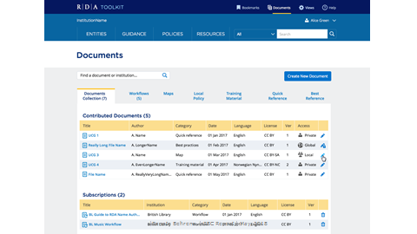 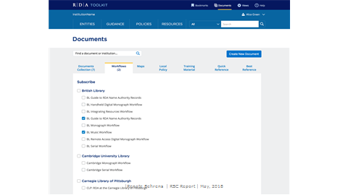 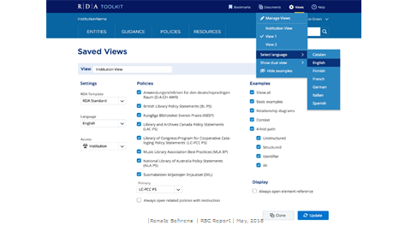 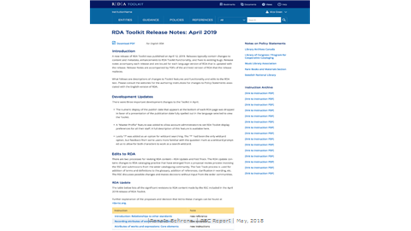

# **Appendix 6: Relationship Designators WG Report**

RSC/AggregatesWG/1

9 August 2016

**Discussion paper: RDA and WGA treatment of aggregates**

<http://www.rda-rsc.org/sites/all/files/RSC-AggregatesWG-1.pdf>

Analyzing this document many questions raise about identifying relationships between aggregation work, creator of aggregation work and creator/s of expressions included in an aggregate. Also it is important to determine the differences between the aggregation work and the whole-part work.

These questions are essential to facilitate better preparation of MARC bibliographic data for export to the linked data environment.

So I would like to ask you to continue this discussion, express your thoughts, suggestions and to propound them to RSC/AggregatesWG.

It is a problem to describe whole-part works, if relationships of whole work and part are not clearly displayed by the author or publisher themselves, e.g., novel series of single creator (“Song of Ice and Fire” (whole work), “Game of Thrones” (part of whole work)). It is often difficult to identify whether the work is a part of series or a part of whole work. The cataloger needs to do a research, which requires additional time and effort, to confirm the assumption that the resource is a part and not the whole work.

**Example:**

*ISBN 9780674417182*

*Eichengreen, Barry, 1952-. The Korean economy : from a miraculous past to a sustainable future.*

*Cambridge, Massachusetts : Harvard University Asia Center, [2015]. (Harvard East Asian Monographs, 0073-0483 ; 375)*

– which is part of multivolume study “Rising to the challenges of democratization and globalization in Korea”(as a result of the research we exactly identified this title as whole work title).

Other cataloguers identified this title also as series title, subseries title, whole work title, other title or cover title in the field 246, this title is also recorded in the note field 500. Such identification problems arise because there is no clearly indicated differences between whole-part work and series information. This situation allows for free interpretation and makes it difficult to identify whole-part work. The only thing that is distinctly said about this resource is that it is part of the bigger work that is included in the series “Harvard East Asian Monographs”. Solution is to record this title as whole work title in field 730 using subfield |i for relationship information:

730 0# |i Contained in (work): |t Rising to the challenges of democratization and globalization in Korea.

It is important to start using already created whole-part work relationship designators in MARC. Question is about relationship designator label. There are several proposals for this relationship designator label and one of them is “aggregated in/aggregation of”. This label could be difficult to translate. Other proposed designator labels (“incorporated in/incorporates” and “included in/includes”) can be discussed. There is a need to clarify differences between abovementioned designators and existing “contained in/container of”.

**Identifying of creator of an aggregation work is highly important for automated creation of work authority records with the Name/Title access points in MARC.** The problem arises when cataloguer creates the description of the aggregation work and have to identify the Work level. Cases when the collection of expressions of one author’s works is compiled by another person (not an author himself) and the title of aggregate given by the compiler does not really reflect relationships between creator and work in a work level (we continue to provide Name/Title AAP for works). Existing practice in creation of MARC records perceives the creator of content as the creator of aggregation work. By automated extraction of Work authority elements from MARC record of such an aggregation work, misleading Work authority record is created. In these cases, it is important to mark proper creator of an aggregation work — compiler (aggregator of — compiler) and creator of content (author of content, illustrator of content etc.).

Problems also occure with the identification of the creator of aggregation work in cases, for example, of book, which contains both – one author works expressions (e.g., correspondence, art catalogs) and compiler’s comments that are equally important content, and it is difficult to determine which dominates and which creator is the creator of the aggregation work. Title of such kind of aggregate usually is given by a compiler. Cataloguers need clear instructions how to create MARC records for aggregation works, in which cases use the AAP for the creator (1XX fields) or use the relationship designator “creator of content” with multiple subproperties (*Author of commentary*, etc.) in additional access points (7XX fields). Maybe the solution could be to record an agregation work under the title (245 BIB; 130 AUT)? The use of relationship designators will show more clearly relationships between aggregation work and agents which are involved in creation various contents in this kind of aggregates and it helps to distinguish work from expression.

Proposals for subproperties to be added to Creator of Content:

* Illustrator of content (e.g. for children books (fairy tales compilations), for other aggregating works, which contains multiple creators of illustrations;
* Composer of content (sheet music; movies etc.).

Proposals for subproperties to be moved to Creator of Content and possibly renamed:

* *Writer of supplementary textual content* rename *Author of supplementary textual content.*

# Appendix 7: Aggregates WG Report

The main task and activity of the RSC AWG during this year were to investigate the impact of the LRM model on the treatment of aggregates and serial in RDA.

The goals of the work of the AWG are:

* to simplify the process of identifying, describing, and relating aggregate and whole-part entities by giving clear instructions about their treatment
* to encourage catalogers to identify and describe aggregate and whole-part entities at the most granular level that they can manage
* to provide explicit relationships that will allow software to make connections between less granular data and more granular data
* to allow a user to:
  + **Find** information about an expression of a work whether it appears alone or with other expressions (e.g., a classic novel included with an introduction or the introduction by itself, or the lyrics of a song appearing without the music); or about a known aggregate (e.g., a well-known anthology of poems, or a song)
  + **Explore** by going from information about an expression in one aggregate to find that expression in other aggregates (e.g., go from information about performed music found in an album to information about that music in other albums or online or given as notated music)
  + **Identify** an expression, whether it occurs in a manifestation alone or as one of two or more expressions in an aggregate, and **Select** and **Obtain** the expression in the preferred manifestation

The RSC AWG submitted discussion papers for the two RSC meetings dedicated to the 3R Project:

* Chicago meeting, May 2017
* Madrid meeting, October 2017

*The Chicago meeting and the AWG model for aggregates in RDA*

The main topics discussed and submitted to the Chicago meeting were:

* The definition of a model for aggregates in RDA
* The distinction of different types of aggregates (Aggregate collections of expressions, Aggregates resulting from augmentation, Aggregates resulting from parallel expressions as defined in the Final Report of the IFLA WG on Aggregates , and a new one Integrated aggregates for resources such as comics, songs, movies, etc.)
* The definition of different types of entities: single entities (i.e. entities without parts or components), whole-part entities (i.e. entities with separate parts) and aggregates entities (entities with components), with the application of the different types of description to each of them
* The proposal of container relationships applicable to each king of entities
* The proposal of Agent to WEM relationships and shortcuts in order to allow a user to search (and find) by the creators of works or contributors to expressions which are incorporated in the aggregate manifestation even if its content is not described in detail.  
  Unfortunately, some shortcuts proposed by the AWG allowing to search by the creator of an augmentation directly at the Manifestation level, without creating an Aggregating Expression and Work, were rejected by the RSC. This approach was inspired by the French way of dealing with augmentations, which will therefore still remain incompatible with RDA.

At the Chicago meeting, the AWG was asked to prepare one of the general chapters put at the very beginning of the code, focused on “Pre-cataloguing decisions: Description and Relationship Decisions for Items, Manifestations, Expressions, and Works” and begun to work on it, with consideration on the mode of issuance and its impact on the choice of a type of description, etc.

Regarding aggregates in RDA, the AWG had to consider the outcomes of the IFLA meeting on LRM and its impact on bibliographic standards and focused its work on continuing resources through the Serials Task Force. The discussion paper presented to the Madrid meeting was the result of this effort.

*The IFLA meeting on LRM alignment and its outcomes*

On August 25th, 2017, just after the IFLA general conference, a meeting was organized with representatives of RDA Steering Committee, FRBR and ISBD Review Groups, and of the ISSN Network. It was intended to discuss major issues of LRM alignment of the main bibliographic standards: namely ISBD, RDA, and the ISSN manual (specialized for serials and other continuing resources). See <http://www.rda-rsc.org/node/543>.

Clément Oury (as representative of the ISSN International Centre) and Françoise Leresche (as member of the ISBD Review Group) attended both this meeting.

Among other issues, the impact of IFLA-LRM for the treatment of aggregates, especially serials, was discussed. It was agreed between the different participants that:

* the “seriality” is a critical aspect of a work, and should not be related to the manifestation level;
* in general, a complete reexamination of the bibliographic data related to serials, was deemed necessary;
* the notion of continuing resources, i.e. resources without a pre-determined end, should be reintroduced in RDA.

The Serials Task Force of the AWG

After this meeting, it was decided that the AWG should focus on issues related on continuing resources. To proceed further, there was a need for an expert advice, with practitioners having a hands-on experience of serials. Therefore, an ad-hoc group, the “Serials Task Force”, was designed, comprising experts of the RSC AWG (Deborah Fritz and Gordon Dunsire), CONSER (US network dedicated to serials: Ed Jones and Les Hawkins) and the ISSN Network (Regina Reynolds for US ISSN Centre, Clément Oury).

The recommendations of the STF were partially endorsed by the AWG report dedicated to “Work, Expression, Manifestation and Items description”.

The RDA toolkit expected in June should take these proposals into account.

The RSC has defined a new concept, to be used in RDA: the “**diachronic works**”, i.e. the works intended to be issued over time, opposed to “static works”. These diachronic works may be either:

* “**determinate**” (e.g. an encyclopaedia released in several volumes over time) or “**indeterminate**” (i.e. continuing);
* “**successive**” or “**integrating**”.

By combining these two pairs of characteristics, it is possible to define four different “extension plans”. For example, a serial is a “successive indeterminate work”. These extension plans are attributes of the “work” level.

A common characteristic of the diachronic resources is the so-called “**WEMlock**” (or “1W:1E:1M cardinality”). It means that each specific manifestation of a diachronic resource is a specific expression, corresponding to a specific work. This statement, also expressed in LRM, is linked to the fact that you can never know when a specific manifestation will provide new content and evolve to a new work. Practically, it means that collocation based on commonality of content is not possible for continuing resources.

The IFLA meeting in August has emphasized the need to re-locate the different data elements to the right IFLA-LRM entity. The STF gave the following recommendations:

* Whenever a data element already belongs to a specific WEM entity for static resources, it will belong to the same entity for diachronic resources. For example, the “publisher” will remain related to the manifestation entity.
* If a data element is specific to diachronic resources, it will be related to the work entity. This is the case e.g. for frequency, ISSN, key-title, etc.

Finally, the AWG and the STF discussed the notion of cluster of works, i.e. the groupings of works with other works sharing common characteristics. Any RDA entity can be clustered. This includes not only works, but also manifestations, agents, places, etc. Clusters may be done:

* on any criterion
* at the discretion of an implementing agency
* within a specific context of use.

An entity can be a member of more than one cluster: e.g., the [1] print version of a television program guide for the [2] greater Ottawa region aimed at [3] French-speaking viewers. To create the cluster, the implementing agency assigns the same nomen-string to each member of a cluster.

The main debates focused on the significance of the distinction “determinate or not”. On one hand, some members of the AWG insisted on the fact that the emergence of the notion of diachronic resource made it less relevant to identify, within the group of diachronic resources, the “indeterminate” (or “continuing”) ones. On the other hand, others experts insisted on the fact that the distinction determinate/indeterminate makes a big difference in terms of practical treatment.

Some recommendation from the EURIG members on this topic still under discussion would be welcome, in order to acknowledge in RDA the concept of “continuing resources”, which is internationally recognized in ISBD, ISSN Manual and in current cataloguing practice

The general chapter “Describing Works, Expressions, Manifestations, and Items”

This chapter is still under completion. It takes into account the decisions about static and diachronic works, aggregating works and expressions, works with amalgamated content, etc.

It provides background information to support the application of guidelines and instructions in the entity chapters on recording attributes and relationships of works, expressions, manifestations, and items. As it stands, it includes:

1. Terminology used in the chapter
2. Decisions to be made before beginning to describe an item in focus
3. Cardinality constraints for WEMI relationships
4. General guidelines on describing Works
5. General guidelines on describing Expressions
6. General guidelines on describing Manifestations
7. Background information on Single Works
8. Background information on Aggregating Works
9. Background information on Static plans
10. Background information on Diachronic plans
11. Basis of identification for a manifestation
12. Modes of issuance for a manifestation
13. Data provenance metadata for works with diachronic plans

Submitted by

Clément Oury (ISSN International Centre – CIEPS)

Françoise Leresche (National Library of France)

# **Appendix 8: Workshop: European cataloguing – further cooperation and involvement**

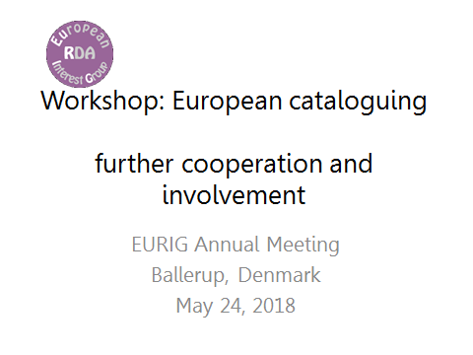

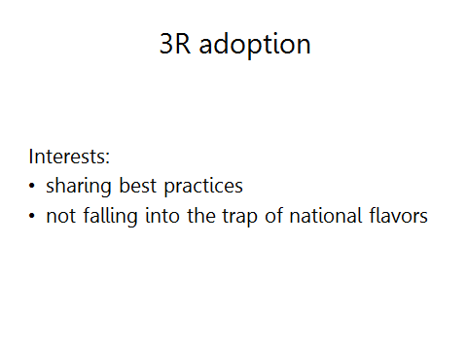 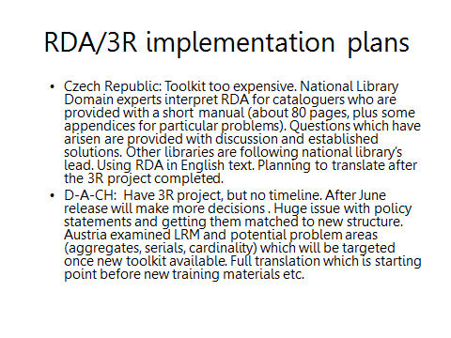 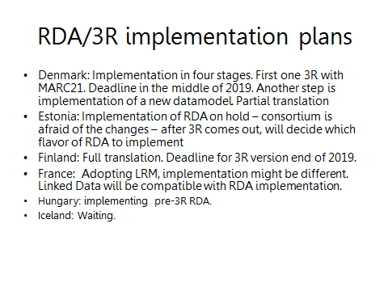 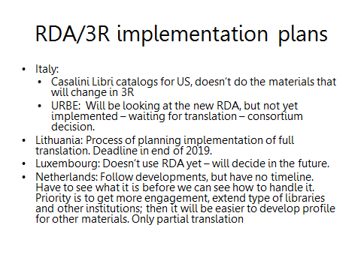 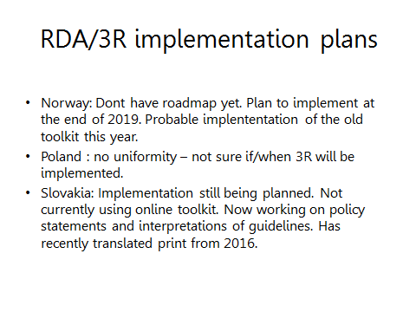 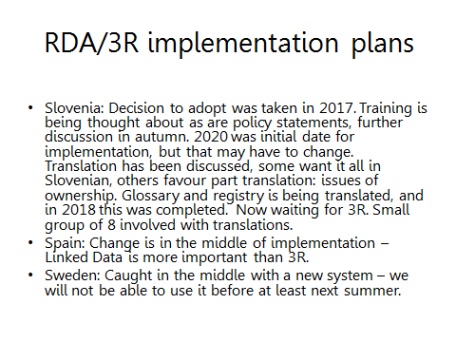 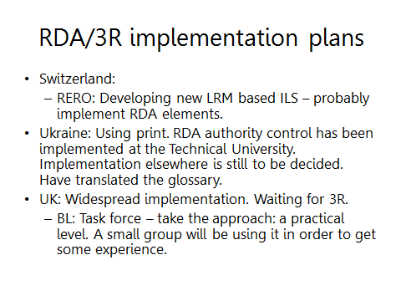 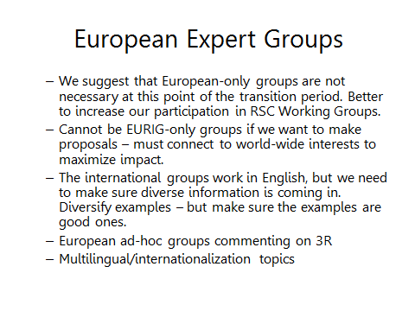 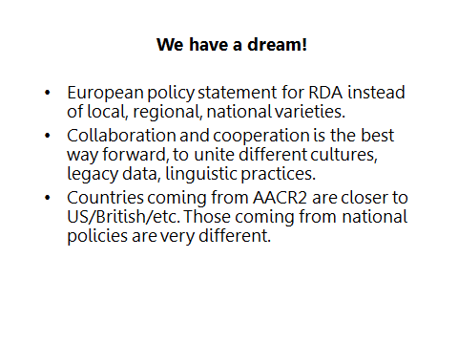 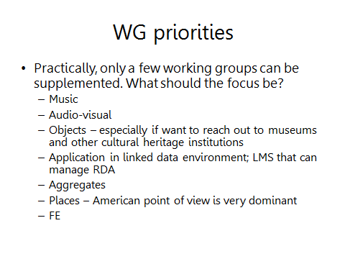

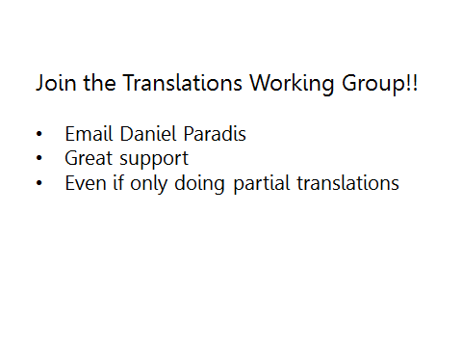 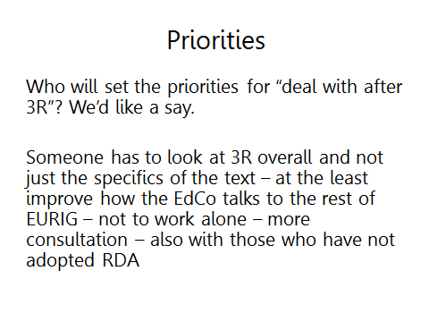 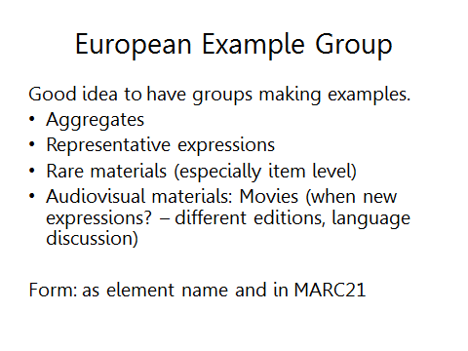

# Appendix 9: Report from the European BIBFRAME Workshop 2017

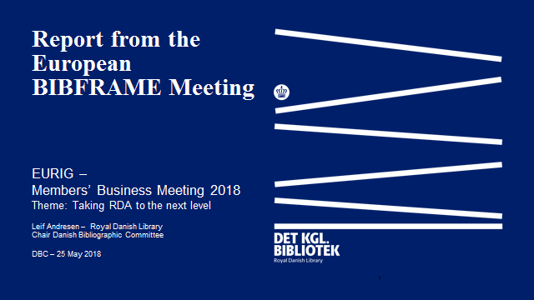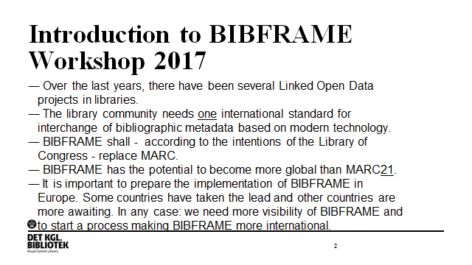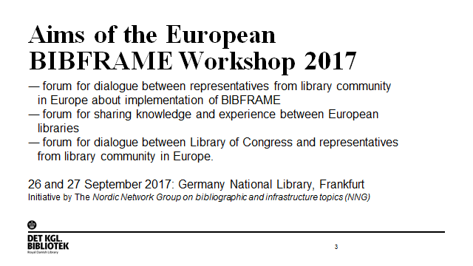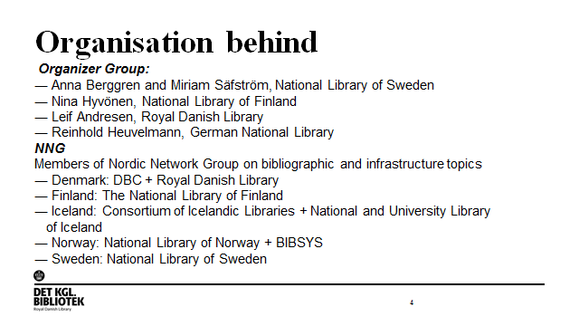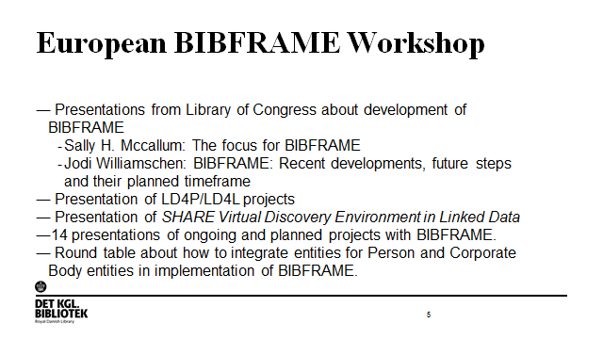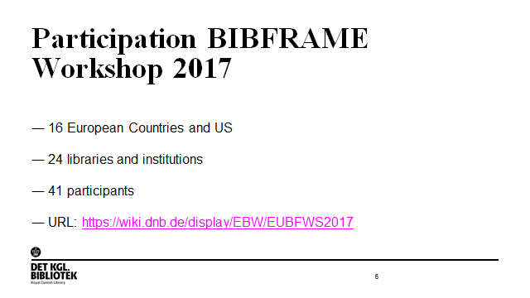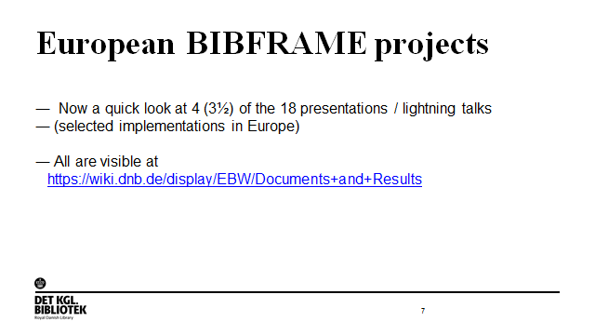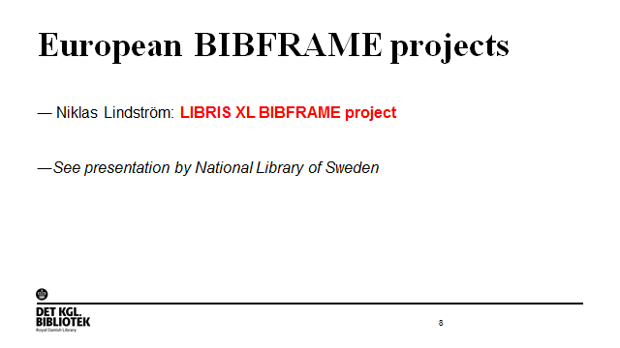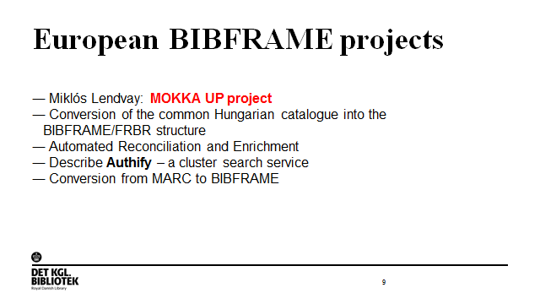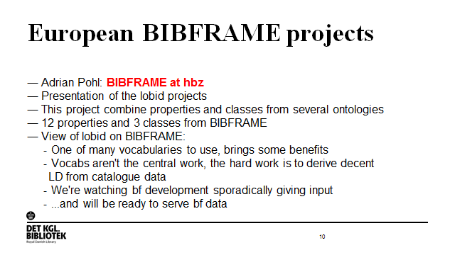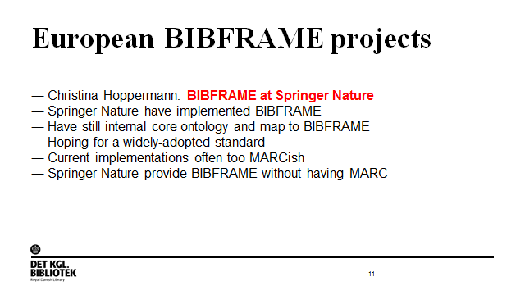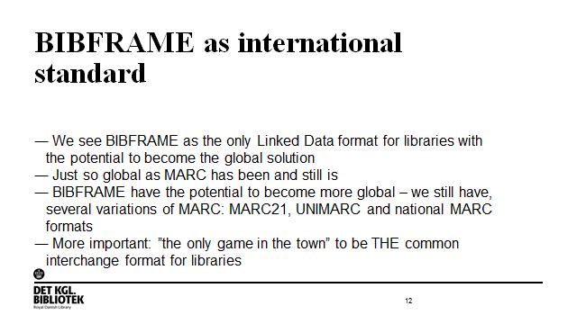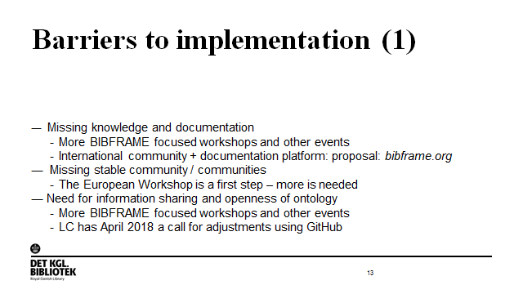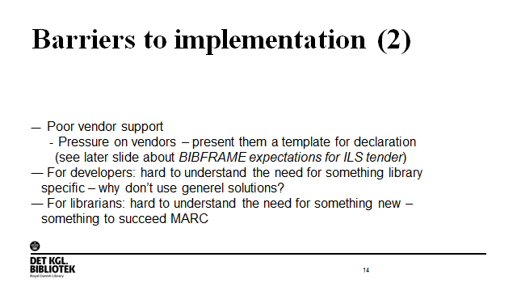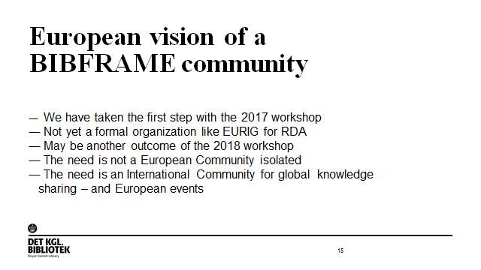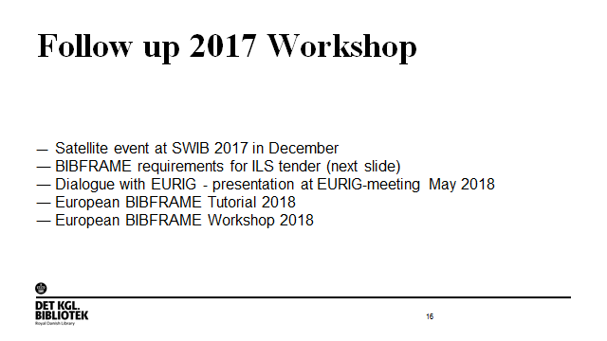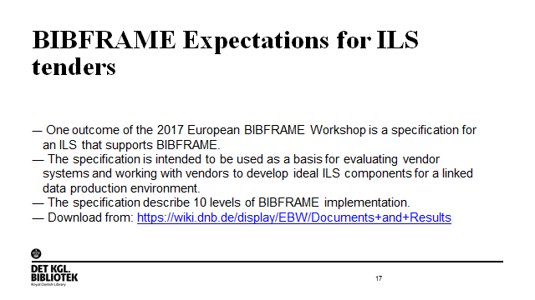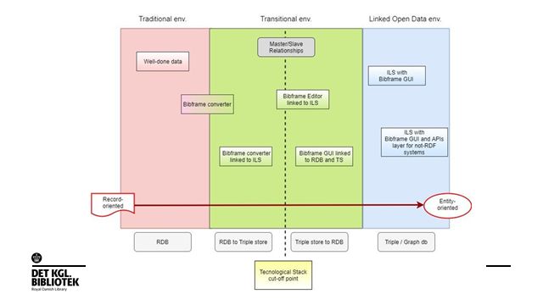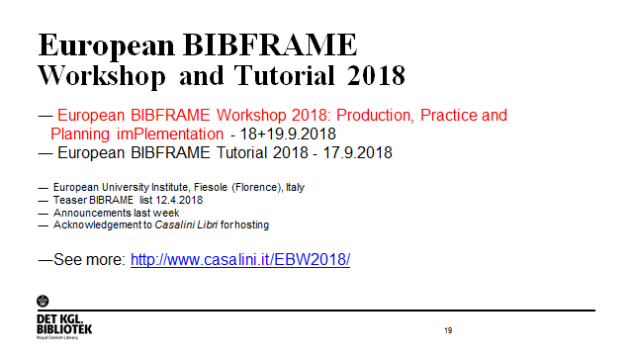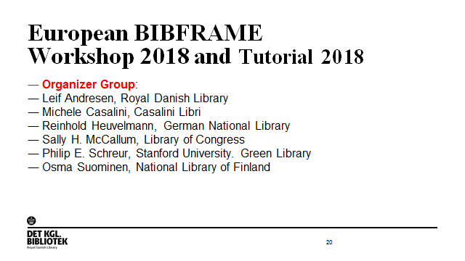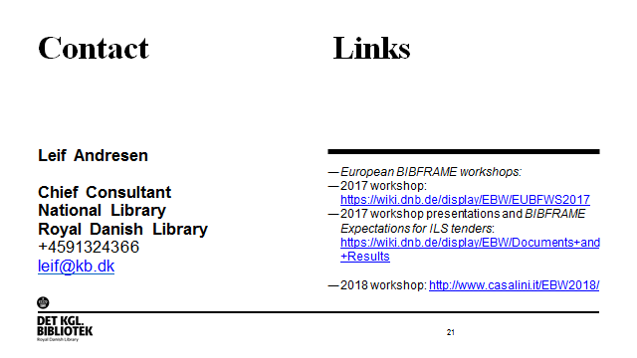

# Appendix 10: The new Libris

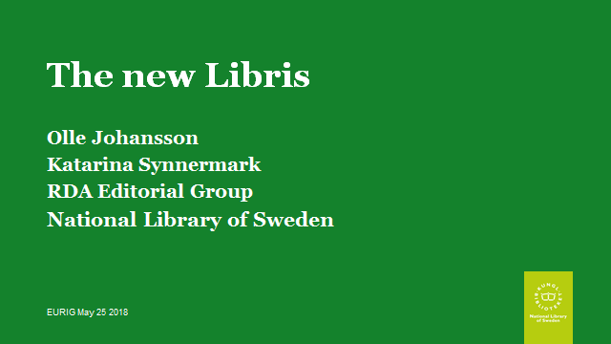

# Appendix 11: Taking RDA to the next level

