RDA: Resource Description and Access
DOC. E
(successor to Anglo-American Cataloguing Rules, 2nd ed.)

LC reference staff briefing: Nov. 30, 2010

#1. Are there RDA records in LC’s database now?
Yes, as of October 1, 2010:

a. bibliographic and authority records created by 50 LC cataloging staff testers for CIP materials and for resources being added to LC’s collections;
b. bibliographic records from other libraries who are CIP partners;
c. bibliographic records from other libraries used for resources being added to LC’s collections;
d. authority records created by some of the NACO participants.

#2. Are these records MARC records and is ISBD punctuation still present?
Yes and yes; for the transition to RDA, most records created by libraries will be MARC records and ISBD punctuation will be used. But, RDA content can be encoded in any schema; RDA does not prescribe display.

#3. Will there be more RDA records in LC’s database even if LC does not implement RDA?
Yes; records in categories b, c, and d in 1. above from libraries who do implement RDA will continue to be added.

#4. How can these MARC records be identified as RDA records?
The MARC 040 field in both bibliographic and authority records will have “rda” in subfield $e; that subfield will not always be the last subfield.

040 $a DLC $b eng $c DLC $e rda

040 $a UPB $b eng $c UPB $e rda $d DLC

040 $a DLC $b eng $c DLC $e rda $d ICU $d DLC

#5. What are the major differences from AACR2 to be seen in RDA records?

a. Fewer abbreviations in bibliographic records -- generally only those found on the resource. No added Latin abbreviations.

On source: Third revised edition
AACR2 = 250 $a 3rd rev. ed.
RDA = 250 $a Third revised edition.

On source: Arlington, Virginia -- ABC Publishing Company
AACR2 = 260 $a Arlington, Va. : $b ABC Pub. Co.
RDA = 260 $a Arlington, Virginia : $b ABC Publishing Company

AACR2: RDA:
p. pages
v. volume(s)
col. color
ill. illustration(s)
port. portrait(s)
sd. sound
si. silent
b&w black and white

Source lacks place of publication & probable place not given:
AACR2 = 260 $a [S.l.]
RDA = $260 $a [Place of publication not identified]

Source lacks publisher:
AACR2 = 260 $a _____ : $b [s.n.]
RDA = 260 $a ______ : $b [publisher not identified]

b. Possibility of found capitalization on the resource not being standardized.

Accepting found capitalization:
245 10 $a Cairo : $b THE CITY VICTORIOUS / $c Max Rodenbeck.
250 ## $a FIRST VINTAGE DEPARTURES EDITION.

Changing found capitalization:
245 10 $a Cairo : $b the city victorious / $c Max Rodenbeck.
250 ## $a First Vintage Departures edition.

c. GMD (now in MARC 245 $h) replaced by three elements:

content type (MARC 336) = fundamental form of communication in which the content is expressed and the human sense through which it is intended to be perceived.
media type (MARC 337) = general type of intermediation device required
carrier type (MARC 338) = format of the storage medium and housing of a carrier in combination with the type of intermediation device

Book:
336 $a text $2 rdacontent
337 $a unmediated $2 rdamedia
338 $a volume $2 rdacarrier

OPAC full record display:

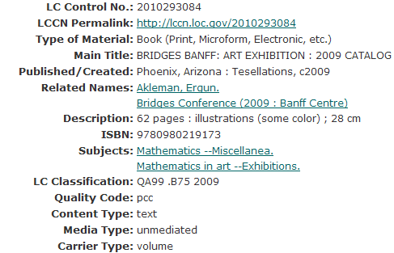

[Other 336-338 examples on p. 7 of this document; will need to consider
placement of this information in the OPAC display]

d. Families as creators (MARC 100) and contributors (MARC 100/700), not just as subjects -- important for archival materials and collections. The authorized access points (what AACR2 calls “headings”) will be for specific family names; the policy of general family names as subject headings won’t change for now.

100 3# $a Andersson (Family : $d 1860-1903 : $c Hult, Sweden)

600 3# $a Anderson family
(subject authority has reference from “Andersson family”)

e. Possibility of identifying information explicitly presented in authority records rather than all being given in MARC 670 field.

046 = special coded dates
370 = associated place
371 = address
372 = field of activity
373 = affiliation
374 = occupation
375 = gender
376 = family information
377 = associated language
380 = form of work
381 = other distinguishing characteristic of work or expression
382 = medium of performance
383 = numeric designation of a musical work
384 = key

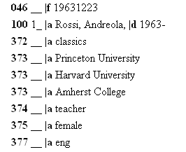

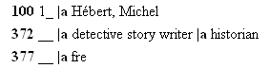

f. Retention in MARC 245 $c of names of all persons, families, and corporate bodies when there are more than three authors, editors, compilers, artists, translators, etc.

AACR2:
245 $a Physics / $c by Susan Brown ... [et al.].

RDA basic instruction:
245 $a Physics / $c by Susan Brown, Melanie Carlson, Stephen Lindell,
Kevin Ott, and Janet Wilson.

or:

RDA option if TOO many:
245 $a Biology / $c by Mary Green [and sixteen others]

g. If two or more persons, families, and/or corporate bodies are equally responsible for the intellectual and artistic content, the first-named entity will be given as the creator in the MARC 1XX field.

100 $a Brown, Susan.
245 $a Physics / $c by Susan Brown, Melanie Carlson, Stephen Lindell,
Kevin Ott, and Janet Wilson.

AACR2: no 1XX field for more than three entities.

h. Possibility of explicit indication of relationships:
(1) person/family/corporate body to a resource (e.g., interviewee, former owner, enacting jurisdiction);
(2) between resources (e.g., sequel, mirror site);
(3) between one person/family/corporate body and another person/family/corporate body (e.g., descendants, employer).

i. Change in authorized access points for parts of the Bible:
(1) Refer to the Old Testament and New Testament by their spelled-out forms;
(2) Omit the name of the Testament in the preferred title for individual books or groups of books.

AACR2 = Bible. N.T.
RDA = Bible. New Testament

AACR2 = Bible. O.T. Genesis
RDA = Bible. Genesis

j. Change in MARC 240 field: no longer “Selections” by itself.

Either:
Works. Selections (if more than one form)
or:
[Term for single form]. Selections
e.g., Plays. Selections

= = = = = =

More 336-338 examples:

Music CD:
336 $a performed music $2 rdacontent
337 $a audio $2 rdamedia
338 $a audio disc $2 rdacarrier

Score:
336 $a notated music $2 rdacontent
337 $a unmediated $2 rdamedia
338 $a volume $2 rdacarrier

Map:
336 $a cartographic image $2 rdacontent
337 $a unmediated $2 rdamedia
338 $a sheet $2 rdacarrier

DVD:
336 $a two-dimensional moving image $2 rdacontent
337 $a video $2 rdamedia
338 $a video disc $2 rdacarrier

Online PDF:
336 $a text $2 rdacontent
337 $a computer $2 rdamedia
338 $a online resource $2 rdacarrier

Website (with maps, text, and photographs):
336 $a text $2 rdacontent
336 $a cartographic image $2 rdacontent
336 $a still image $2 rdacontent
337 $a computer $2 rdamedia
338 $a online resource $2 rdacarrier

Or subfield $a may be repeated in one 336 field:
336 $a text $a cartographic image $a still image $2 rdacontent

